Lab 4 Assignment

1. Find the Integral of x2ex ln(x) limit x=0 to x=2 using monte carlo integral. Use 100, 1000, 5000, 10000 data points and print the integral value and error estimate. Also draw error vs n graph. Here n= number of points.
2. Find the area under the curve below using the Monte Carlo **Integral**.

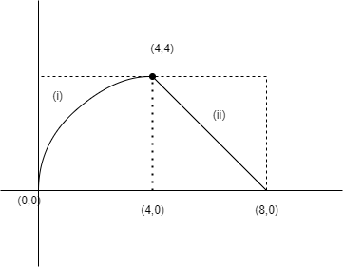

Equation of curve - (i) is : y2 = 4x

Equation of (ii) is: y = 8 - x

Simulate this area for n=100,1000,5000,10000 points. For each value of n, print the area and estimated error of integral.

Instructions:

1. Solve the problems. Keep the two .py files in a folder and zip it. Upload the zip folder on ELMS
2. Do not copy code. Any kind of copy detected will be given negative full marks. That may cause failure in this course. Be careful.
3. Copy will be checked in Standard MOSS copy checker.